KICKS

FRONT KICK

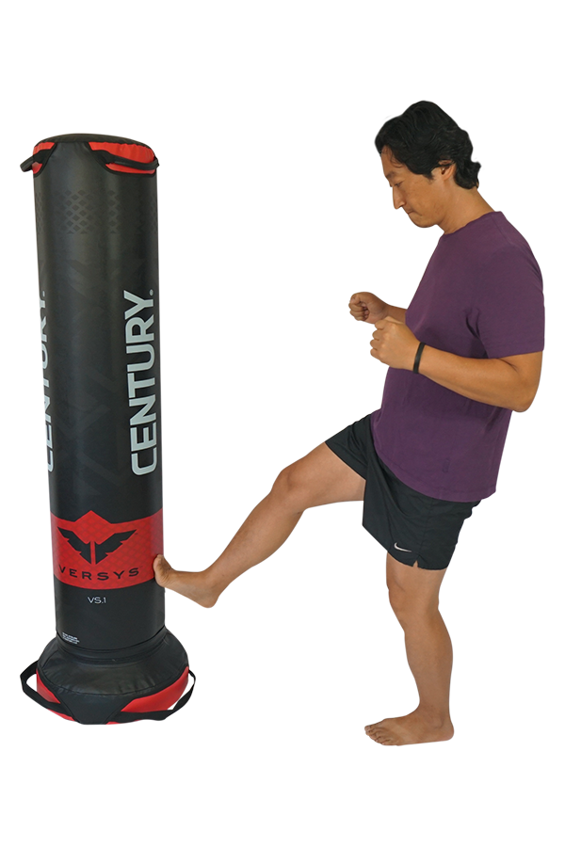
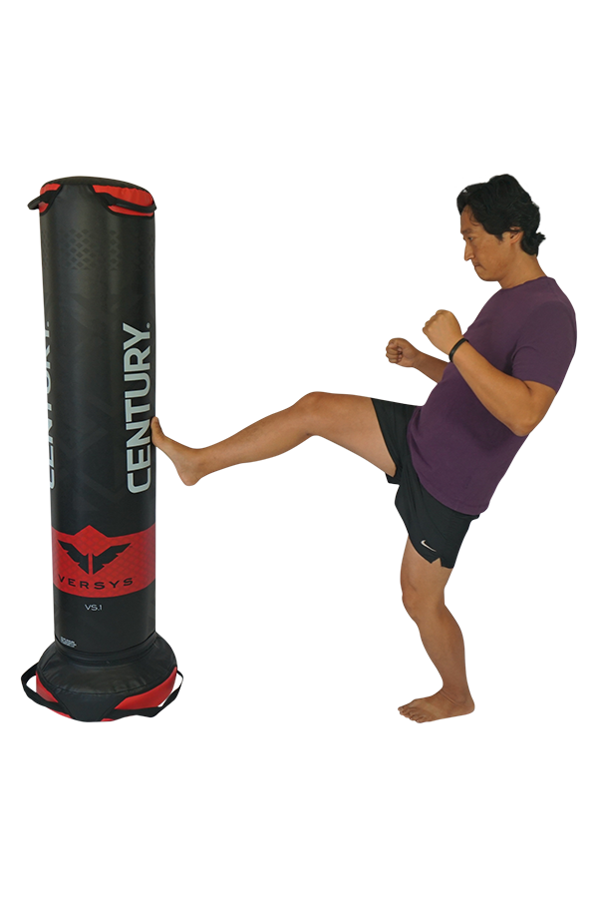

SWING KICK

ROUND KICK

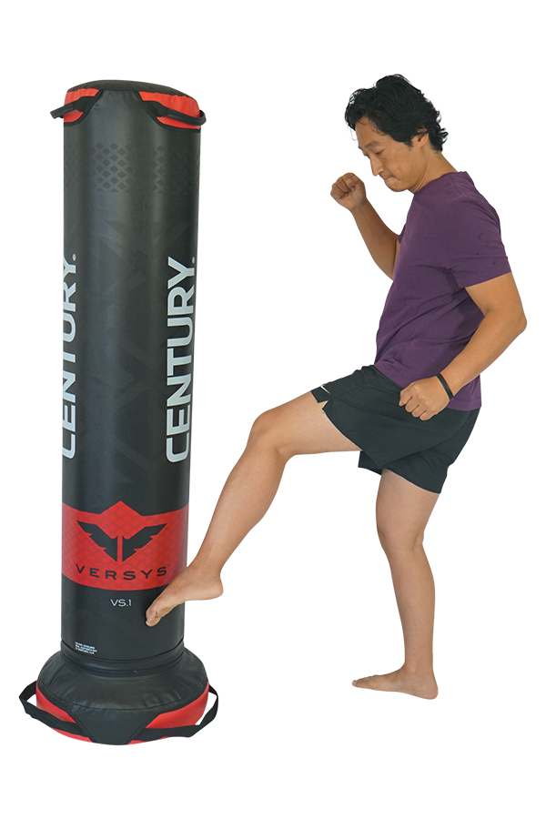
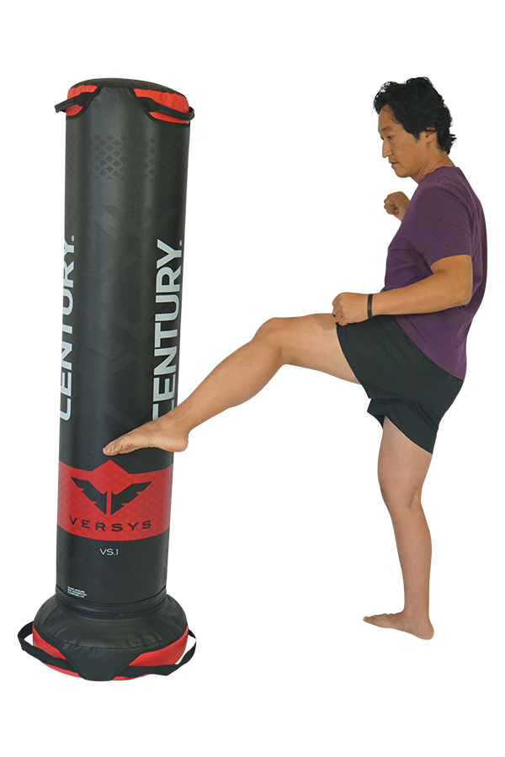
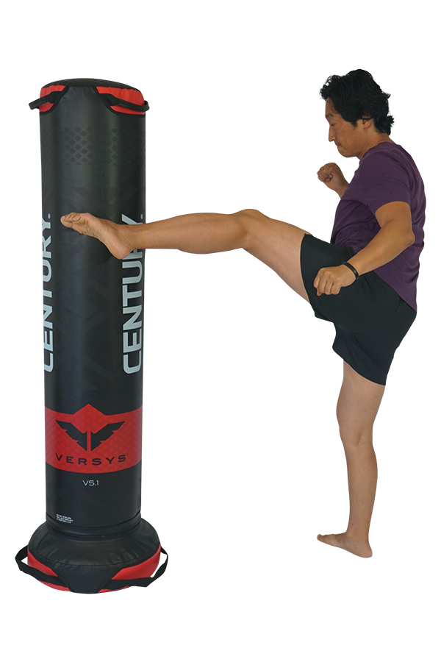

SIDE KICK

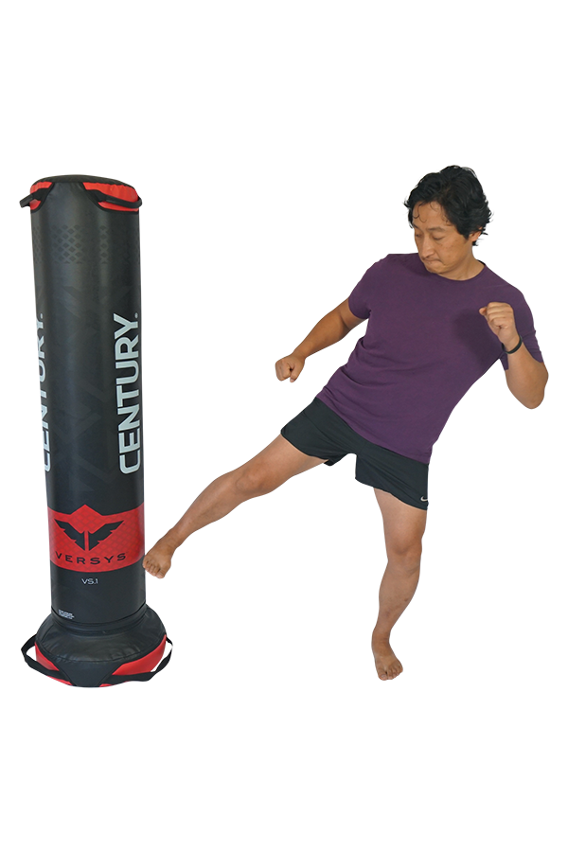
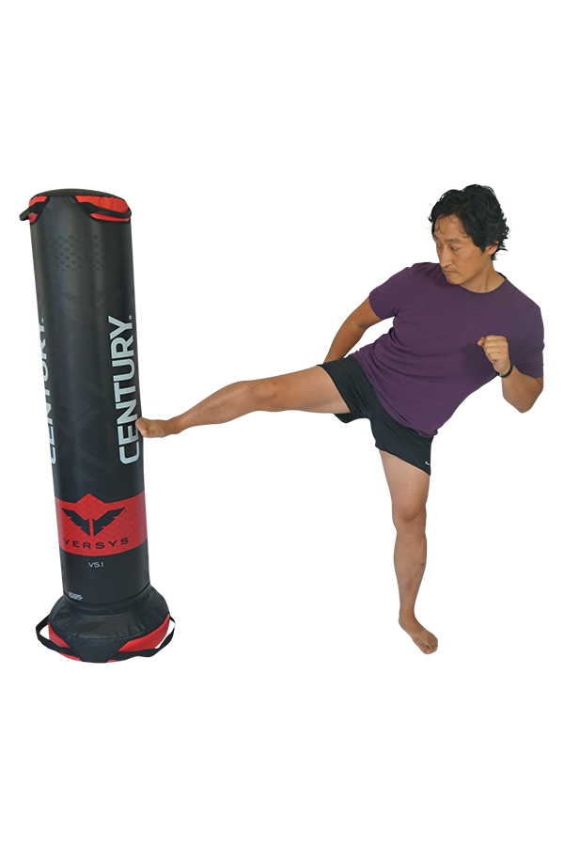
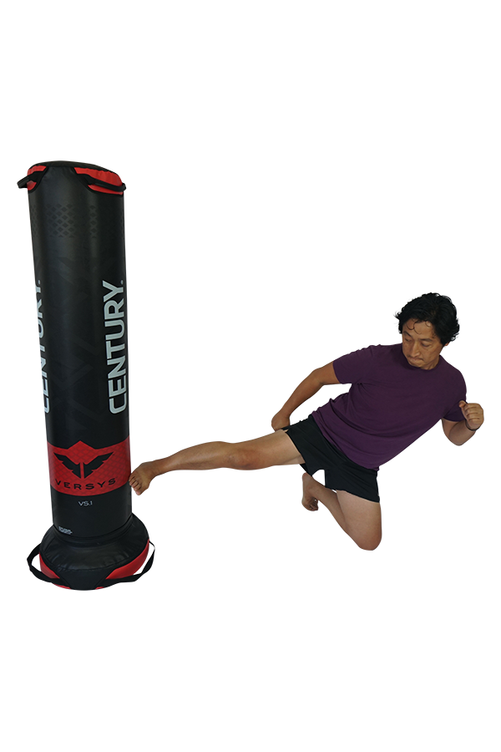

DONKEY KICK

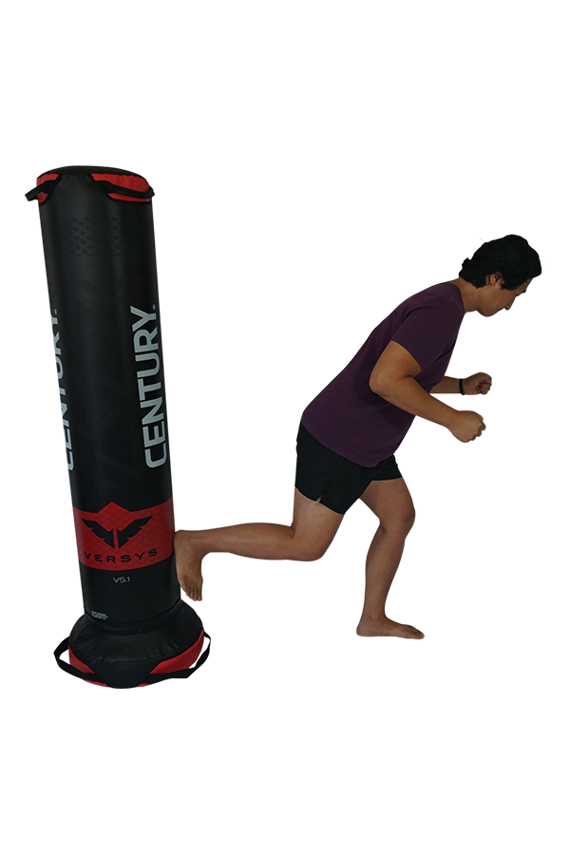
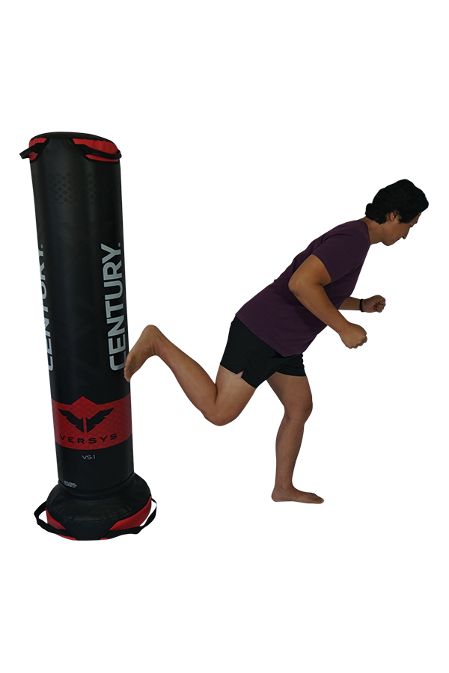
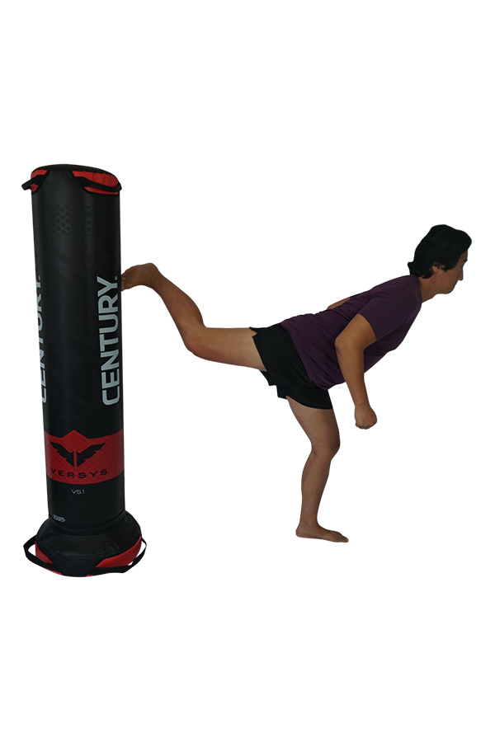

AX KICK

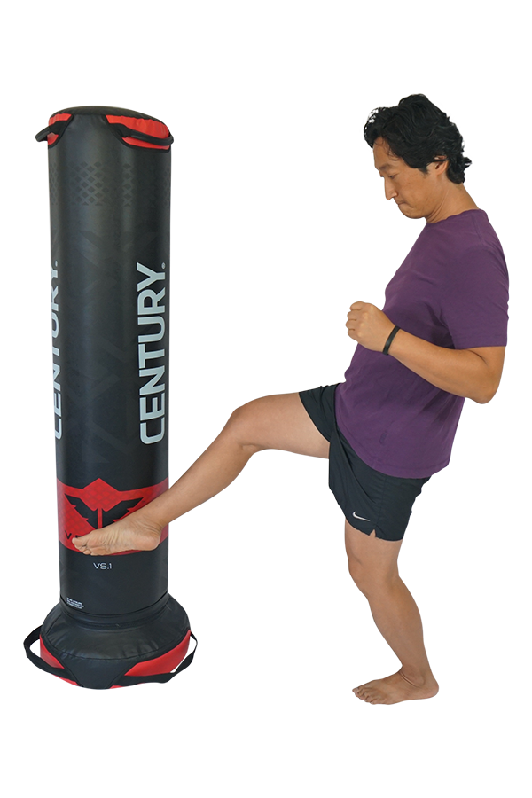
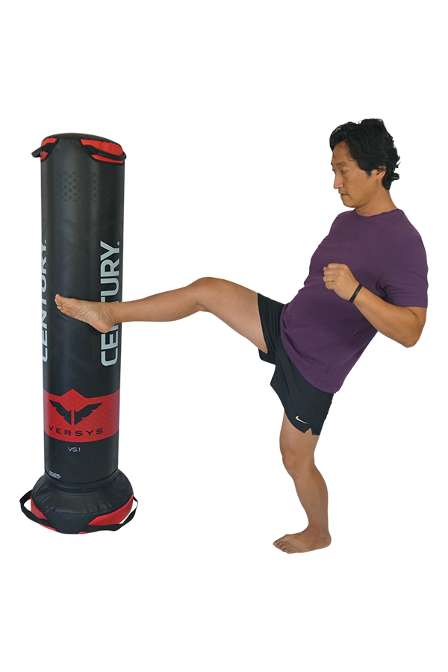
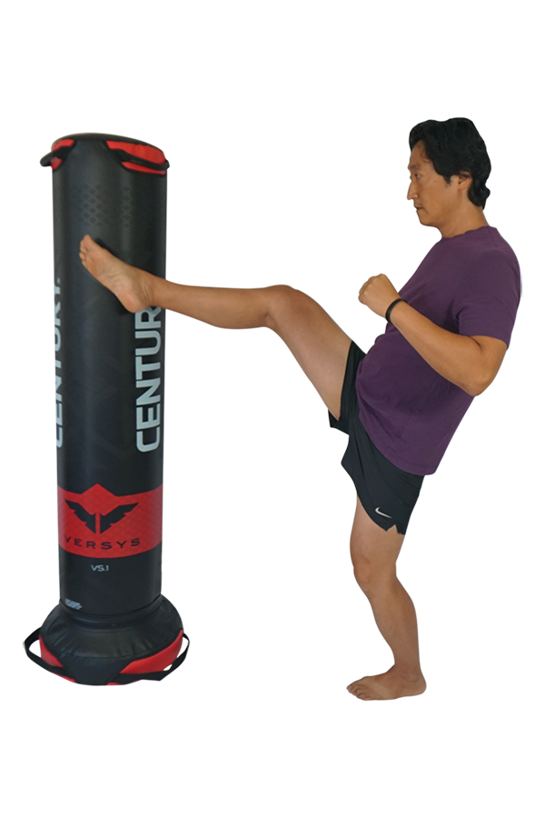

PUNCHES

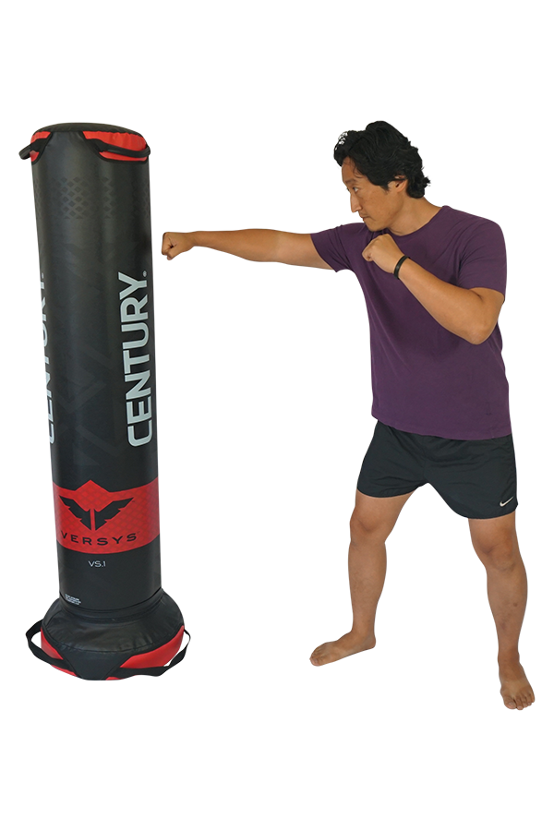
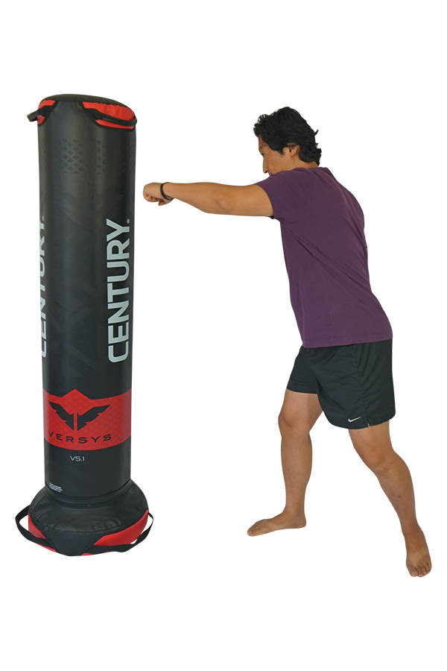
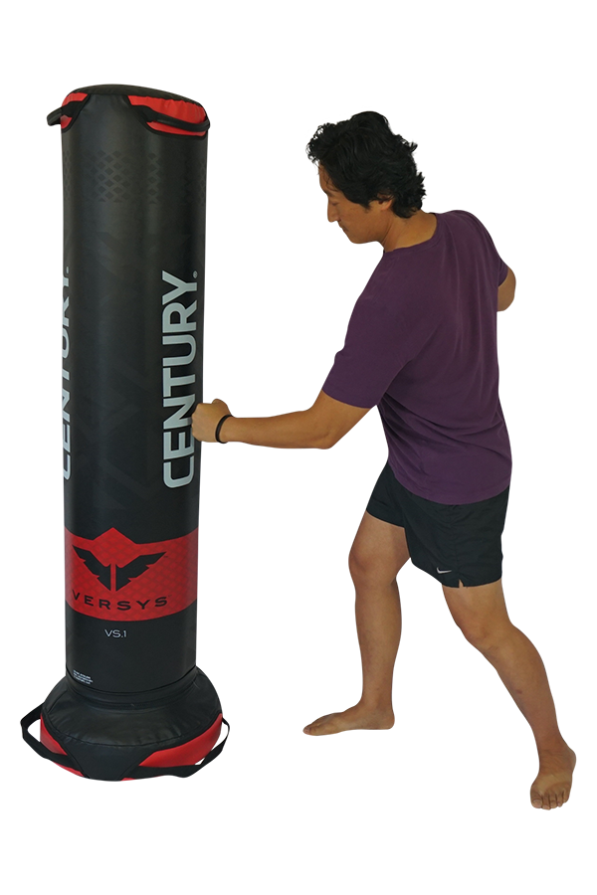

CHOPS

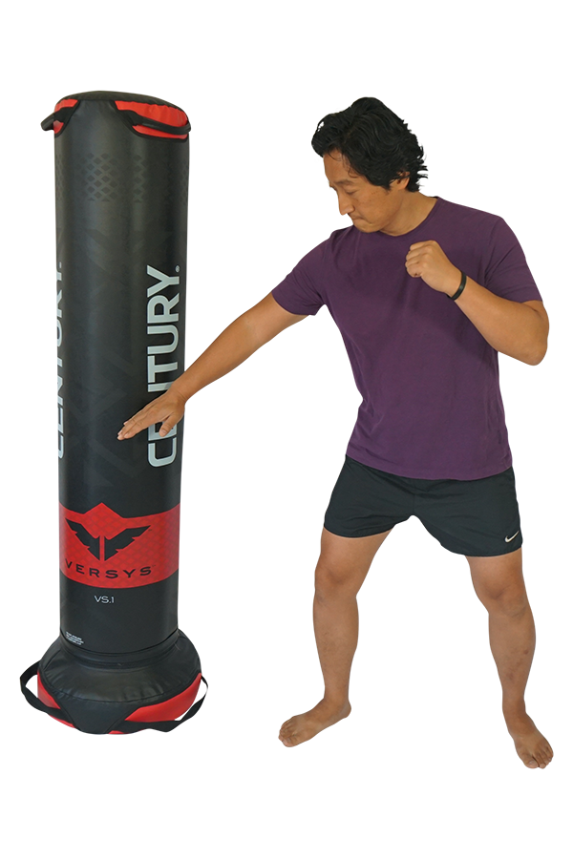

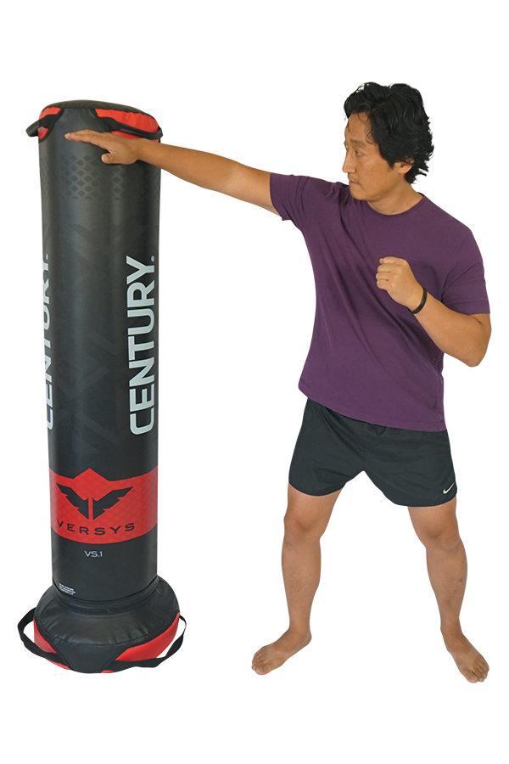

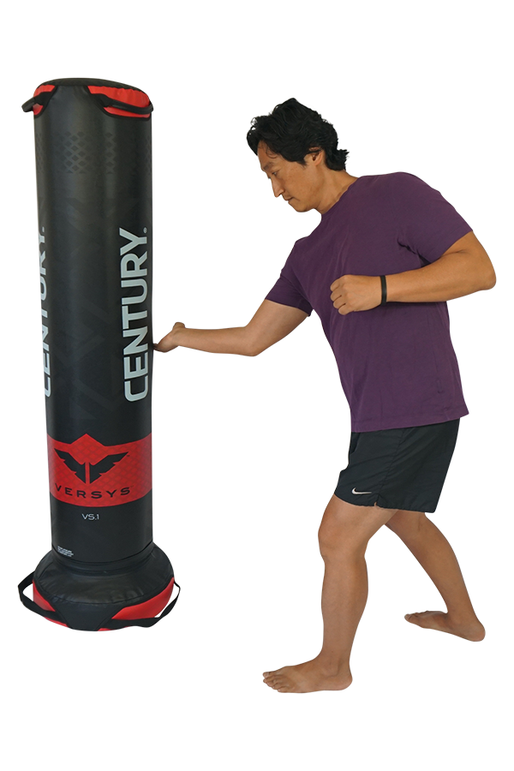

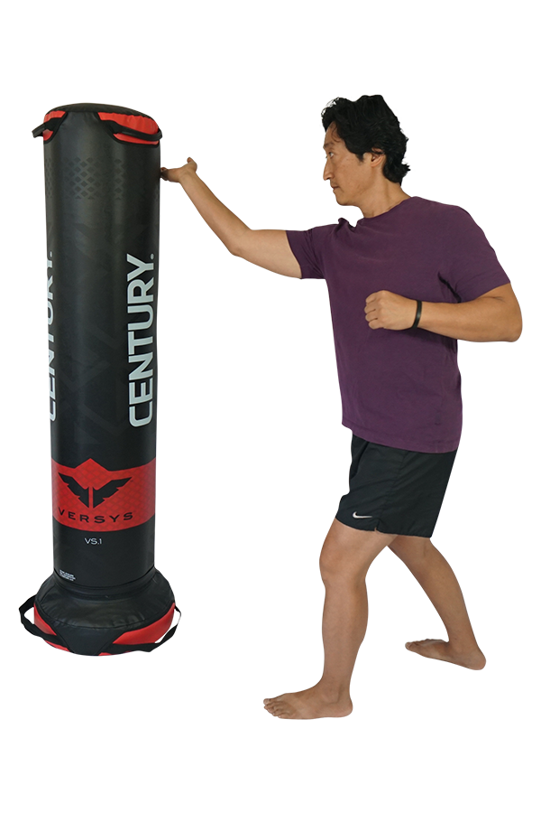

Back Hands

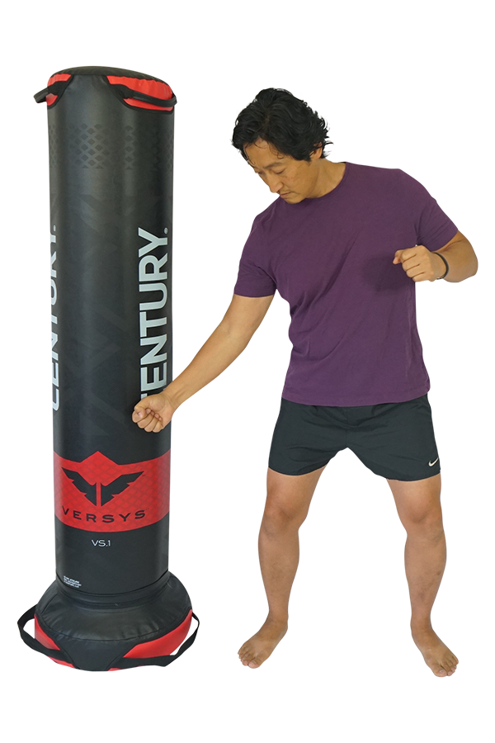
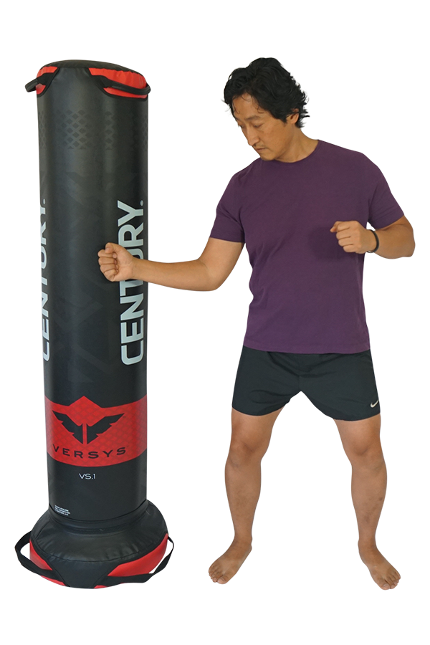
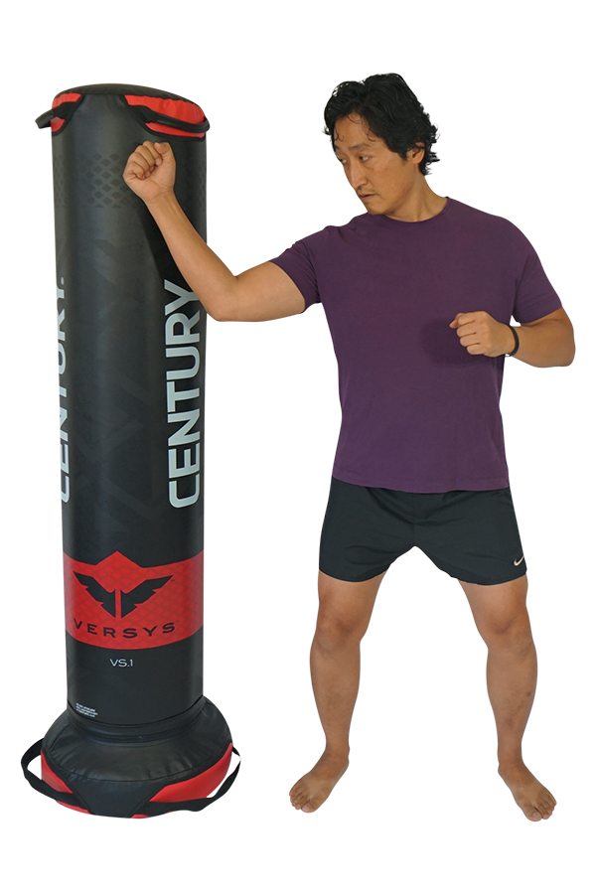

Supported Warrior (Supported Virabhadrasana 2)  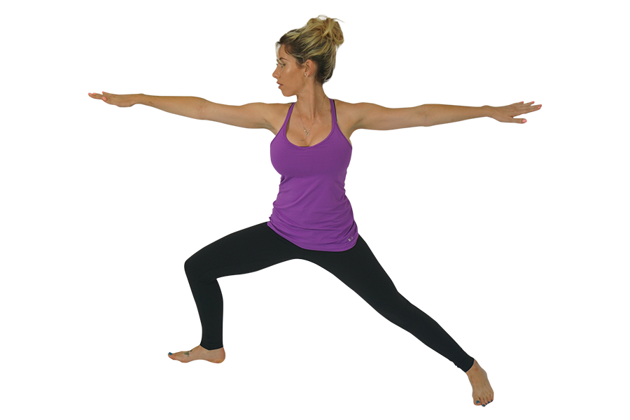 | INDICATIONS  - Entire body  Contraindications  - Shoulder surgery
Instructions
- Begin back against wall for support
- Step your feet about three to four feet apart
- Point your right toes forward
- Bend your right knee until your knee in over your ankle in a 90 degree angle
- Straighten your arms out to your sides
- Straighten your fingers
- Belly button pulled in
- Press sacrum down
- Stretch your neck up
- Gaze over your right fingers
- Hold for ten deep breaths switch sides

Modifications
- Place your hands on your hips
- Chair for balance support

*All contraindications include recent surgery and pathologies.

8 Point  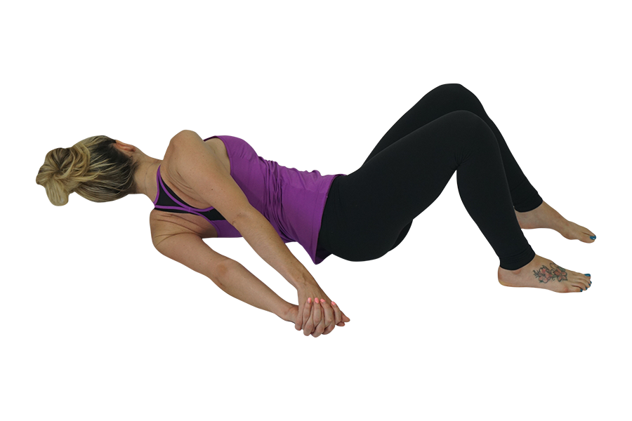 | INDICATIONS  - Shoulder Pain,  - Posture  - Fibromyalgia,  - Arthritis,  - Osteoarthritis  Contraindications  - Dislocation  - SLAP lesion  - Post Surgery
Instructions
- Lay on your belly arms out to the sides
- Slide block under left side of face (this protects your neck when in final pose keeping your neck in align with your spine)
- Make sure back of palms are pressed into mat, thumbs pointing down towards feet
- Bend your right arm and press palm of hand into the mat up and bend your right knee
- With your right hand start to push yourself onto your left side
- Reach to the sky with your right arm and place the sole of your foot onto the mat behind your left knee
- Rotate your torso around to clasp hands together behind your back
- Bend left knee and bring left foot to meet right
- Hold until for 10 deep breathes
- To come out of pose release grip
- Straighten left leg
- Roll onto belly straightening right leg
- Repeat on other side

Modifications
- Don’t interlace fingers
- Do one arm at a time keeping your other arm resting on your side
- Only bend one knee leaving the other straight
- Don’t bend your knees just do arm at a time

*All contraindications include recent surgery and pathologies.

Bridge (Setu Bandhasana)  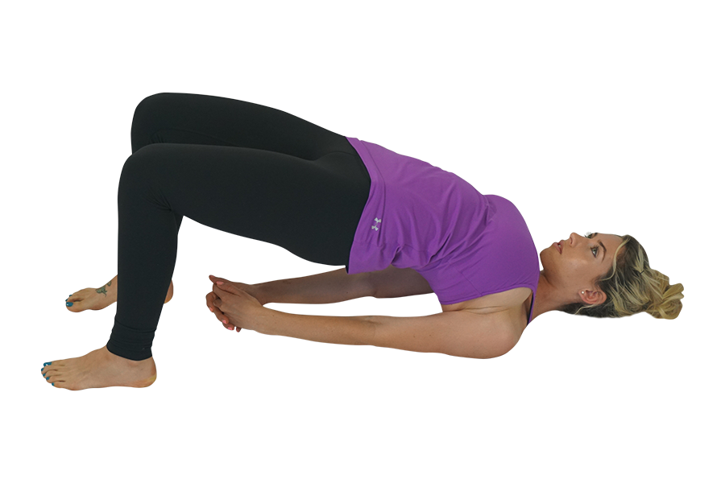 | INDICATIONS  - Back pain,  - Shoulder Pain,  - Arthritis,  - Carpal Tunnel  - Hip/Knee  - Posture  Contraindications  - Cervical surgery
Instructions
- Lay on your back
- Let spine melt into the mat
- Place soles of feet flat on mat
- Knees pointing up to the sky
- Tuck chin towards chest to lengthen back of neck
- Arms by sides of body palms open towards the sky
- Start to walk your heels up to sitz bones keep heels until your heels are aligned with your knees
- Reach fingers tips to touch back of heels or as far as comfortable
- Draw your belly button to meet your spine
- Press into the soles of your feet
- Press your sacrum into the mat and slowly one vertebrae at a time press up keeping your knees in align with your hips and your hips with your shoulders
- Keep a long neck (to protect your neck from any injury do not turn your neck in this posture)
- Gaze is up to the sky
- Keeping your palms pressing into your mat; for extra leverage hold on to edges of your mat
- Or to go deeper interlace your fingers behind your back pressing them into the mat
- Hold for a few breaths or until satisfied
- As you exhale slowly release grip and roll down on vertebrae at a time

Modifications
- No interlace of fingers, hands as comfortable palms face down
- Prop a block or bolster underneath the sacrum

*All contraindications include recent surgery and pathologies.

Camel (Ustrasana)  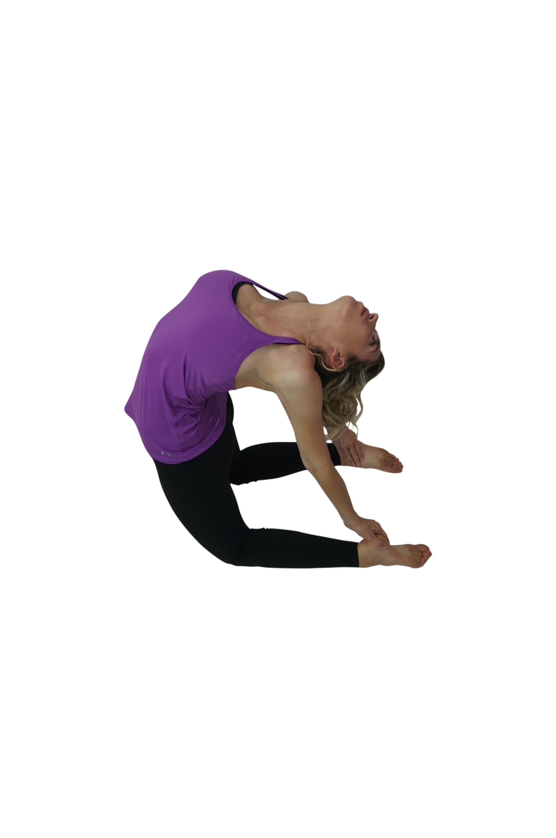 | INDICATIONS  - Knee pain,  - Back Pain  - Posture  - Arthritis,  - Osteoarthritis  Contraindications  - Cervical fusion
Instructions
- Fold your mat in half (folding the mat will help if you have sensitive knees)
- Sit up on your knees
- Hips aligned directly over knees
- Press into the tops of your feet
- Rotate your inner thighs in and back
- Reach you tail bone down; pull pelvis up
- Pull your belly button
- Roll shoulders back and down
- Try to keep your chin down
- Reach one hand at a time to your sacrum fingers pointing down
- Lift up through your heart
- Gaze up
- Soften lower back
- Take a deep inhale and on your exhale slowly reach for your heels one at a time; bringing your fingers to the inside and your thumbs to the outside
- Relax and soften your neck
- Hold this for about ten deep breaths
- To come out, slowly bring one hand at a time to your lower
- Slowly sit back down onto your heels
- Close your eyes (this prevents any dizziness)

Modifications
- Keep hands on lower back
- Tuck toes

*All contraindications include recent surgery and pathologies.

Chair w/Twist (Utkatasana) | INDICATIONS  - Shoulder Pain,  - Back pain  - Fibromyalgia,  - Arthritis,  - Osteoarthritis  Contraindications  - Disc Herniation
Instructions
- Stand arms by sides, toes touching, heels slightly apart
- Open your toes wide
- Pull belly button to spine
- Pull shoulders back and down
- Bring your hands to the center of your chest to prayer
- Bend your knees
- Sit back as if you were going to sit back into a chair (Guide the underside of your thighs so they are parallel with the floor, hips no lower than the knees)
- Pull your belly button in
- Lengthen through top of head
- Neck long
- Keeping your hands in prayer bring your right elbow to your outer left knee
- Check your knees make sure they are even (pull the left back to realign them)
- Keep your gaze up and back
- Shift weight into heels (you should be able to wiggle your toes)
- Hold for about ten breathers and switch sides

Modifications
- Hand on hips or at heart center¸
- If feet hip distance apart, place block in between thighs

*All contraindications include recent surgery and pathologies.

Crescent Moon (Chandrasana) | INDICATIONS  - Back pain,  - Shoulder pain,  - Posture  - Arthritis  - Osteoarthritis  - Knee stretch  Contraindications
Instructions
- Sit on mat knees together back onto your heels
- Bring arms above head
- Interlace fingers keeping your index fingers out
- Pull your Belly button into your spine
- Pull your shoulder back and down (make sure your shoulders aren’t “up in your ears”)
- Press your left hip to the left
- Reach and stretch your arms to the right
- Make sure shoulders are in align (imagine your are in-between two panes of glass)
- Point your fingers up and to the back conner of the room
- Hold for ten deep breaths and switch sides

Modifications
- Only one hand overhead the other hand on hip
- Try feet apart
- Bend elbows or separate hands overhead like you are holding a beach ball
- If you are not able to stand, lay on your mat on your back and follow steps (this is called Banana Posture or Bananasana)

*All contraindications include recent surgery and pathologies.

Child’s Pose (Balasana)  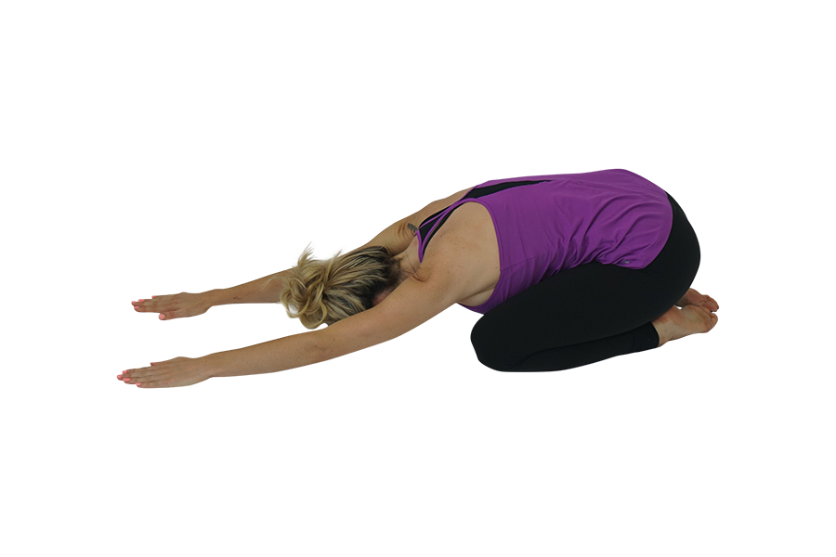 | INDICATIONS  - Back Pain,  - Head aches  - Posture  - Knee stretch  Contraindications  - Disc herniation
Instructions
- Start on all fours
- Slowly press your hips to your heels
- Stretch your fingers out in front
- Rest your forehead on the mat
- Hold for ten deep breaths

Modifications
- Place rolled up mat under knees
- Let arms rest down by sides

*All contraindications include recent surgery and pathologies.

Cobra (Bhujangasana)  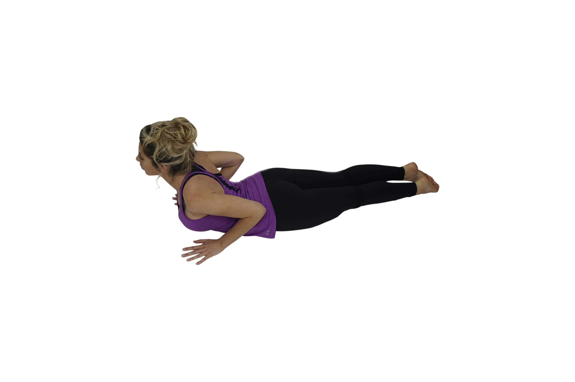 | INDICATIONS  - Shoulder Pain  - Fibromyalgia  - Back pain  Contraindications  - Wrist fractures
Instructions
- Lay on belly
- Place palms on hands on the mat under the shoulders
- Finger tips in line with front of shoulders
- Hug your elbows into your side body
- Chin on mat
- Press tops of feet into the mat
- Inhale; lift torso up
- With little to no pressure in your hands
- Engage your thighs
- Knees off the mat
- Shoulder blades back and down
- Gaze forward to avoid crunching
- Hold for ten deep breaths

Modifications

*All contraindications include recent surgery and pathologies.

Dolphin (Makarasana)  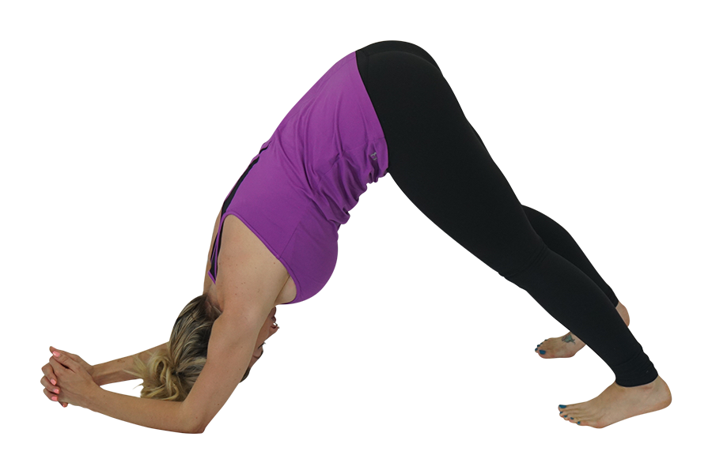 | INDICATIONS  - Back Pain  - Shoulder Pain  Contraindications  - Acute Achilles pain/rupture  - Post surgery shoulder
Instructions
- Begin on your hands and knees.
- Align your wrists directly under your shoulders, and your knees directly under your hips.
- Lower your elbows and forearms to the floor
- Press palms together and interlace fingers
- Keep your weight even across both forearms.
- Press your shoulder down and back (think of pinching a pencil between your shoulder blades)
- Belly to spine
- Tuck your toes and lift your knees off the floor.
- Press your spine back and up to the sky
- Relax your neck
- Hold for ten deep breaths

Modifications
- Bend knees

*All contraindications include recent surgery and pathologies.

Downward Facing Dog (Adho Mukha Svanasana)  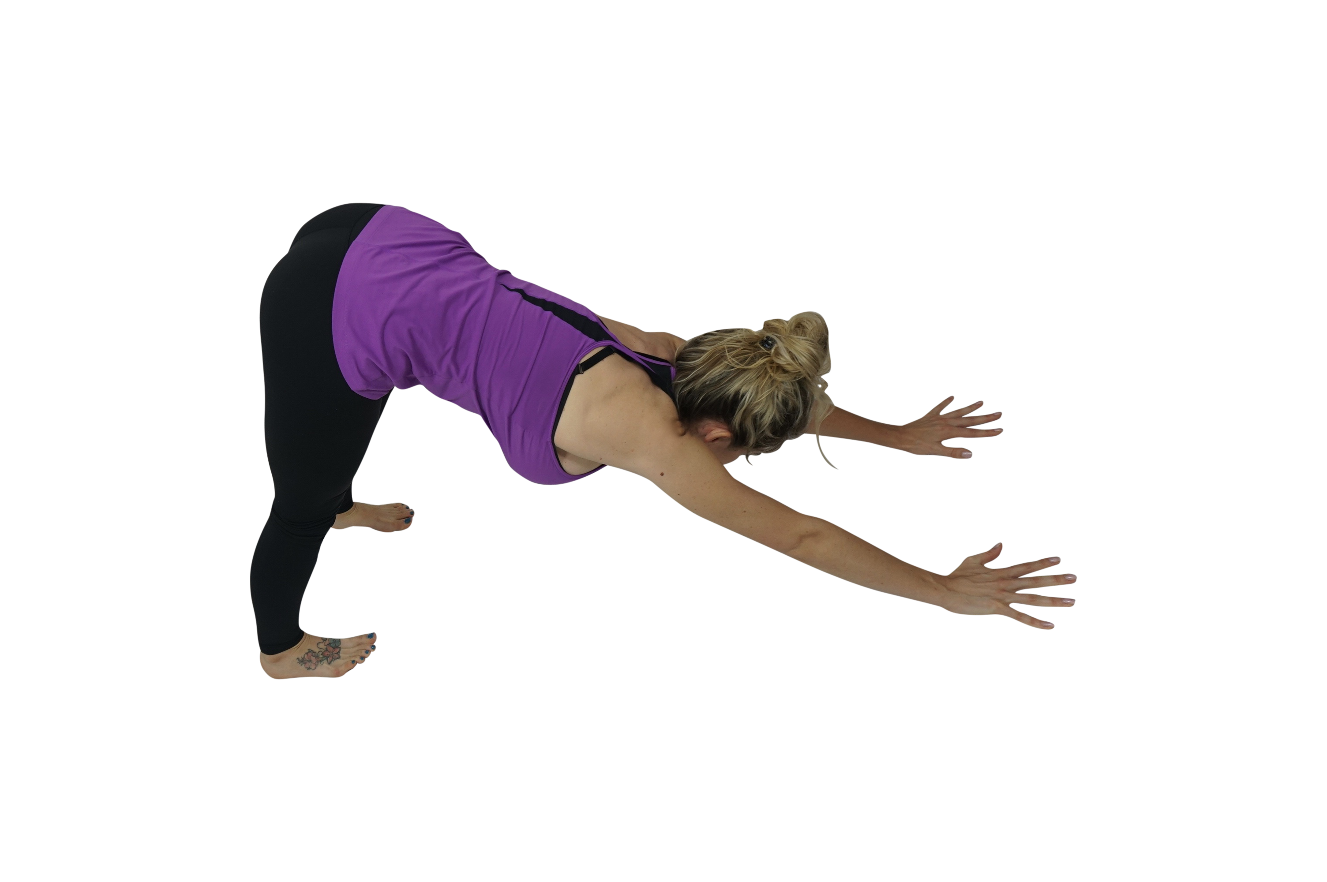 | INDICATIONS  - Back Pain,  - Fibromyalgia  - Posture  - Core  Contraindications  - Wrist issues  - Achilles issues
Instructions
- Start on all fours
- Glue palms to the floor shoulder width apart
- Spread your fingers wide; your thumb and index finger should be in an L shape
- Curl your toes
- Press back and up
- Lift your hips up to the sky
- Shoulders away from your ears
- Rotate your triceps in and up
- Relax your neck
- Rotate your inner thighs in and up
- Press your heels into the mat
- Belly to spine
- Hold for ten deep breaths

Modifications
- Come down on elbows (dolphin) to relieve pain in wrists
- Use wall behind your feet (good for Fibromyalgia)

*All contraindications include recent surgery and pathologies.

Dragon  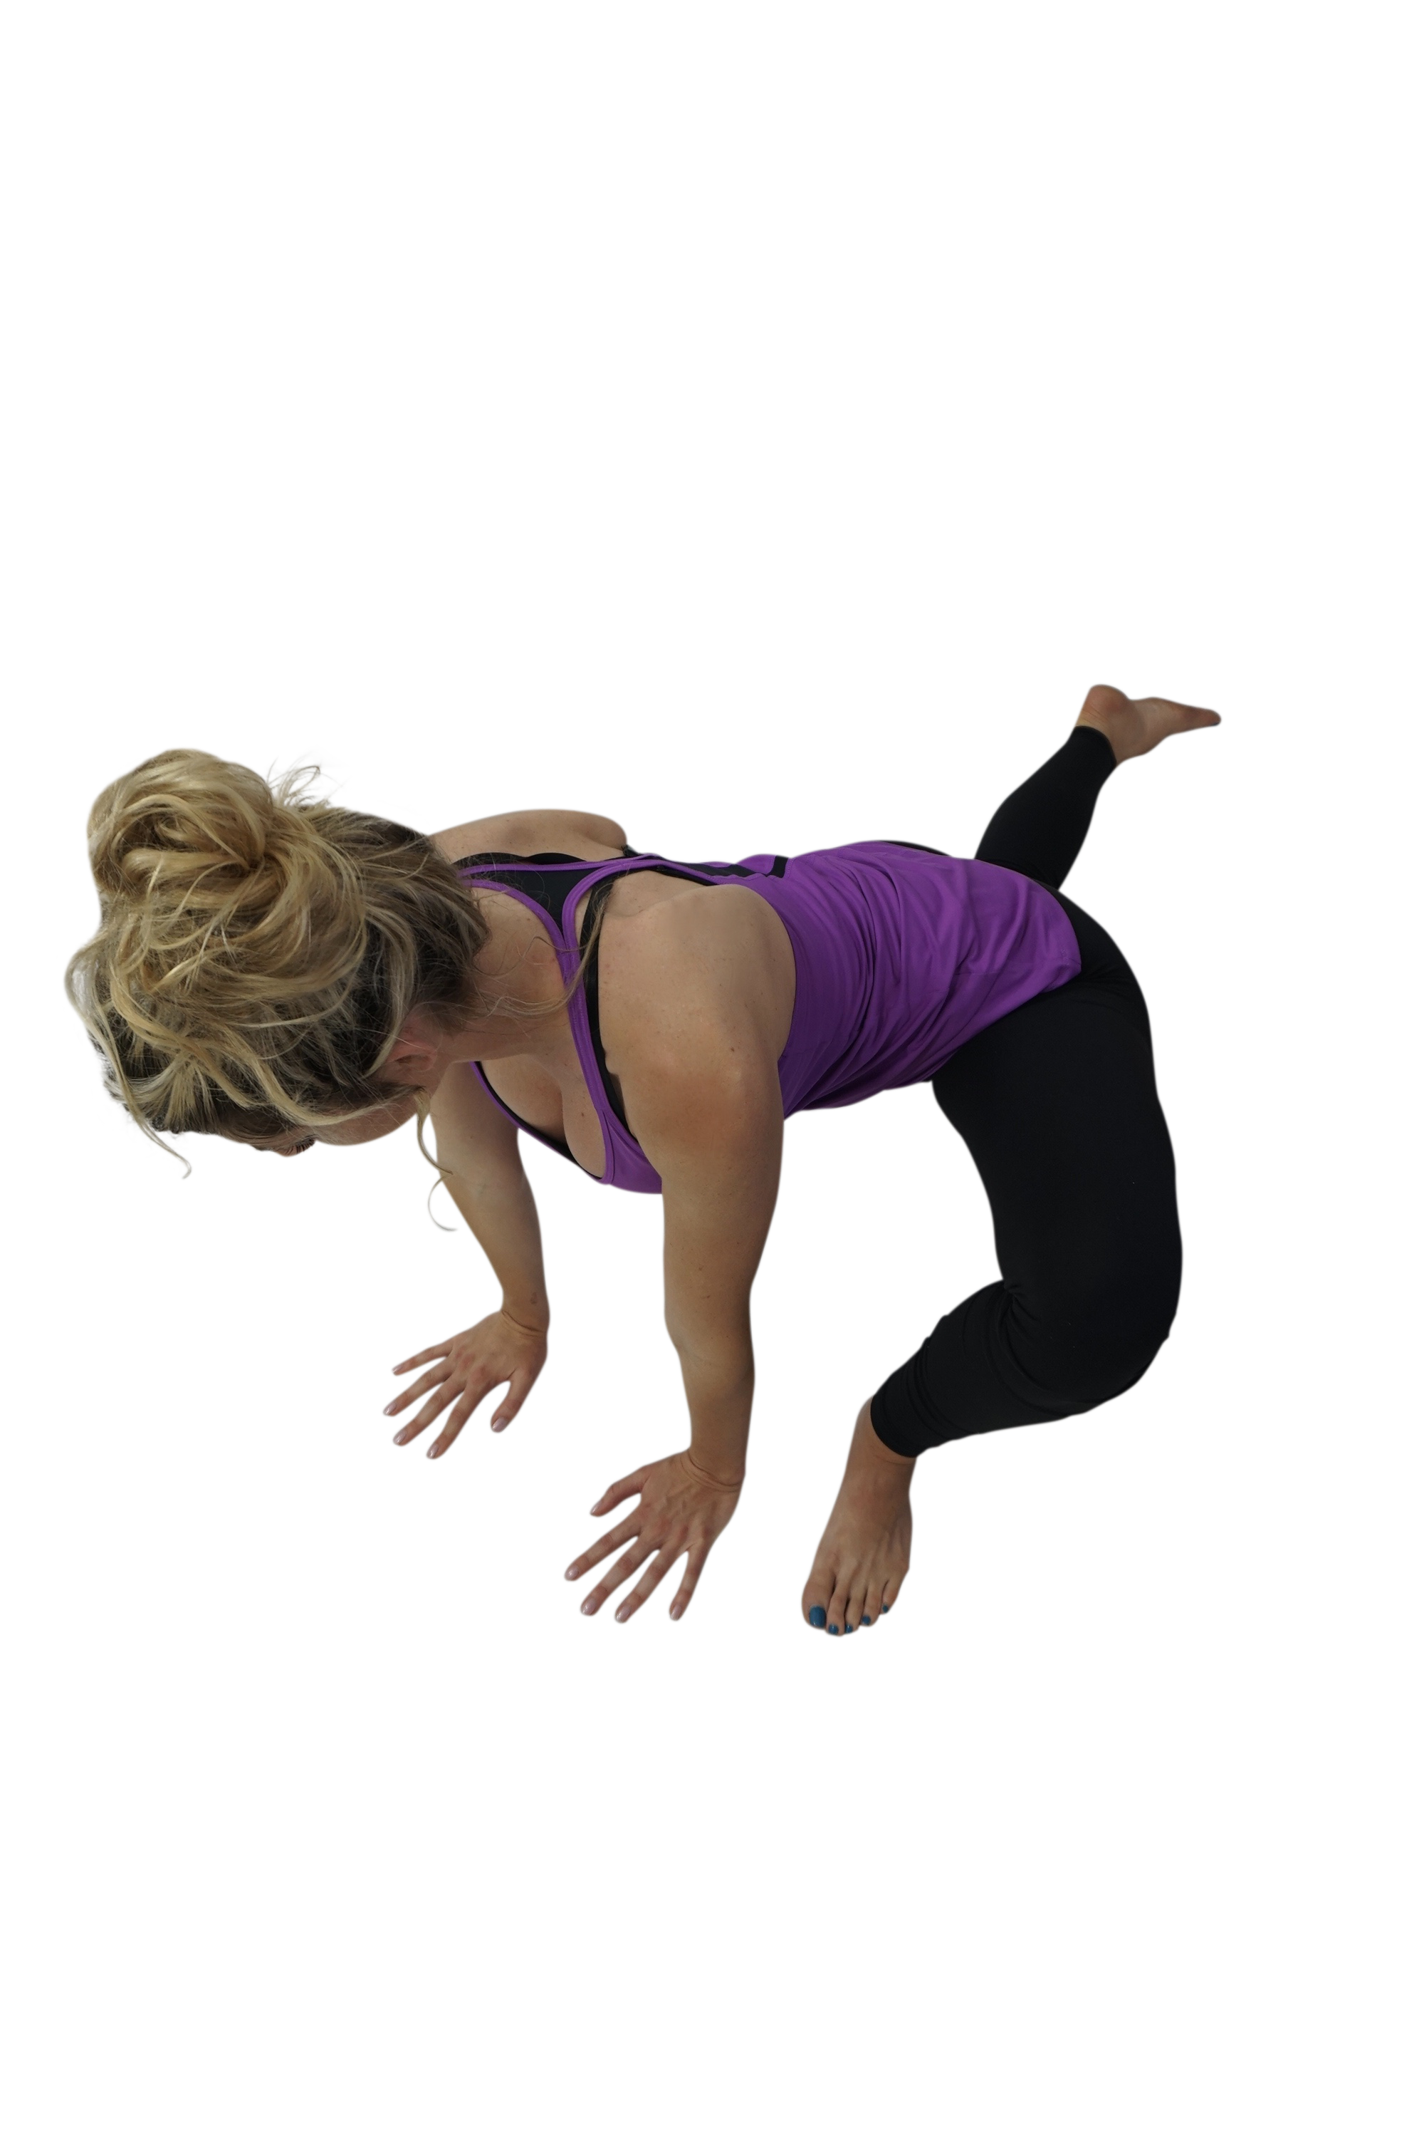 | INDICATIONS  - Lower back pain  - Hip  Contraindications  - Disc herniation
Instructions
- Start standing tall with hands on your hips
- Step your right foot back come into a lunge
- Hinge forward and Place both hands on sides of you to the ground (for balance)
- Slower lower your right knee all the way to the ground
- Gently and slowly inch your left foot out about 5 inches further to the left
- Bring hands to the ground to the center of your body
- If you can bring your elbows onto the ground and rest your head on your wrists

Modifications
- Don’t

*All contraindications include recent surgery and pathologies.

Extended Puppy Dog (Uttana Shishosana)  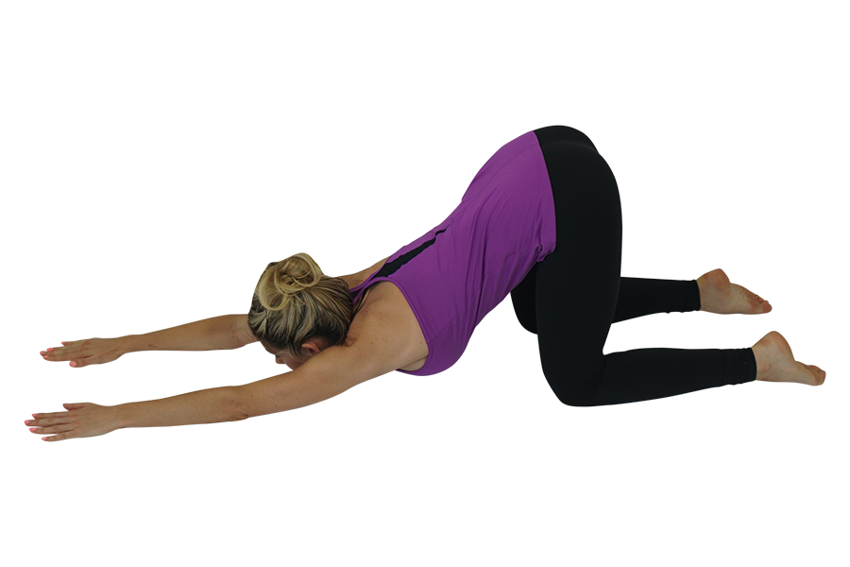 | INDICATIONS  - Shoulder Pain  - Back pain  Contraindications
Instructions
- Start in tabletop
- Reach and extend your arms out in front of you
- Keep your hips over your knees
- Shoulder blades together
- Rest your chin on the mat
- Pull your belly button to your spine
- Pull back through hips and stretch through arms
- Hold for ten deep breaths
- To come out walk hands back and bring hips to meet the heels and slowly roll up

Modifications
- Allow forehead to gently drop to the floor
- Place forehead on block if you can only get halfway into pose

*All contraindications include recent surgery and pathologies.

Standing Forward Fold w/Clasp (Uttanasana with Mudra Hands) | INDICATIONS  - Back pain,  - Head aches,  - Shoulder Pain  - HS stretch  Contraindications  - Disc herniation
Instructions
- Stand with your feet hip-width apart
- Pull your belly button to your spine
- Bring your shoulders blades back and down
- Interlace fingers behind your back
- Slowly fold over your knees (as far as your body allows you to go)
- Relax your neck
- Hold for ten deep breaths

Modifications
- Bend knees
- Reach arms as far behind to touch as you can hold onto a strap or towel if they do not reach

*All contraindications include recent surgery and pathologies.

Knees to Chest  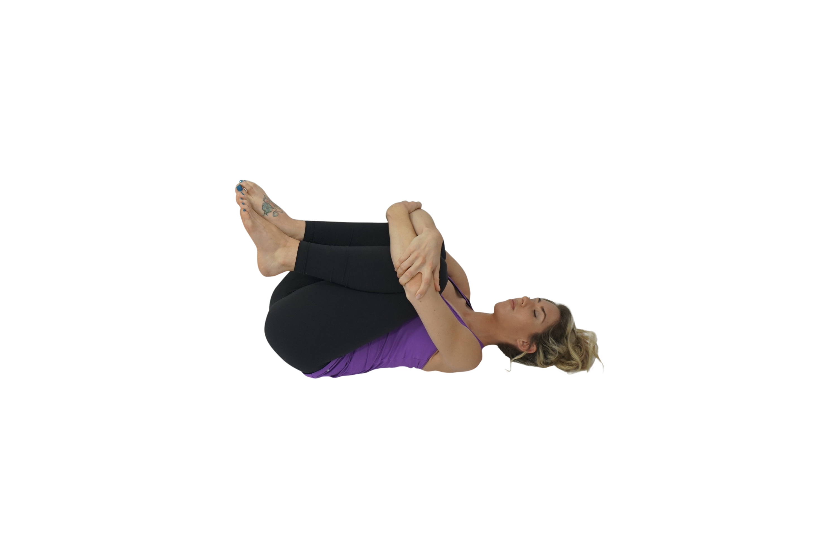 | INDICATIONS  - Fibromyalgia  - Head aches, Arthritis  - Osteoarthritis, Back Pain  Contraindications  - Total Hip Replacement
Instructions
- Begin laying on your back
- Bring your knees to your chest
- Grasp onto your forearms or interlace your fingers around your knees
- Press back of neck into the mat
- Hold for ten deep breaths

Modifications
- Draw knees slightly to the side body to avoid larger chest or stomach
- Strap or towel

*All contraindications include recent surgery and pathologies.

Legs Up the Wall (Viparita Karani) | INDICATIONS  - Head aches  - Lower back Pain  - Posture  - Arthritis  - Lower nerve stretch  Contraindications  - If doing at home, make sure someone is watching.
Instructions
- Find space by a wall t wall
- Sit with right side against the wall
- Bring knees to your chest
- Lay on left side
- Roll onto you back while you swing and straighten legs up on the wall
- Hold for ten deep breaths

Modifications
- It’s not necessary for your sit bones to touch the wall.
- For more support under your neck, place a small, rolled towel beneath the back of your neck.

*All contraindications include recent surgery and pathologies.

Locust One Leg (Salabasana)  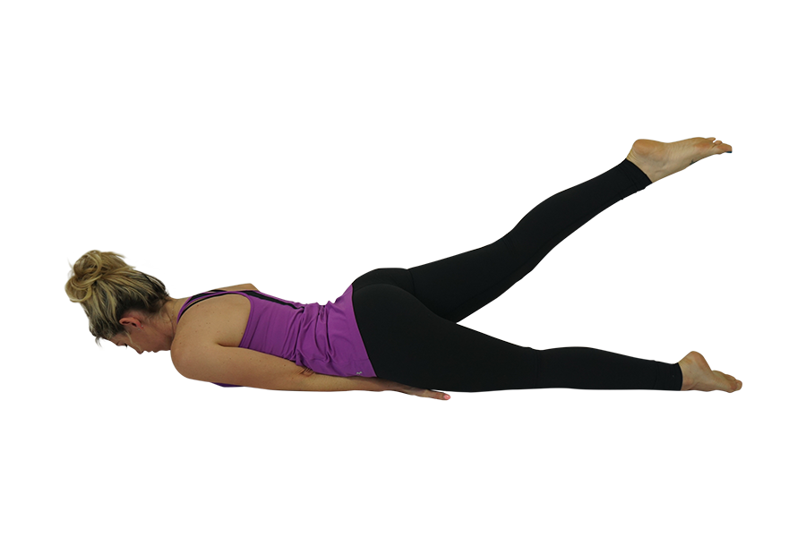 | INDICATIONS  - Back Pain  - Fibromyalgia  - Arthritis  - Osteoarthritis  - Carpal tunnel  Contraindications
Instructions
- Start on your belly
- Palms down and one hand at a time, place our hands under your pelvic bone
- Place chin on the mat
- Slowly lift one leg up
- Point the points
- Rotate inner thigh up towards the ceiling
- Switch legs
(This is not about how high one can lift the leg. It is about how much one is stretching and reaching through the toes.)

Modifications
- Keep arms out hands under shoulders to help stabilize

*All contraindications include recent surgery and pathologies.

Lying Hero (Supta Virasana)  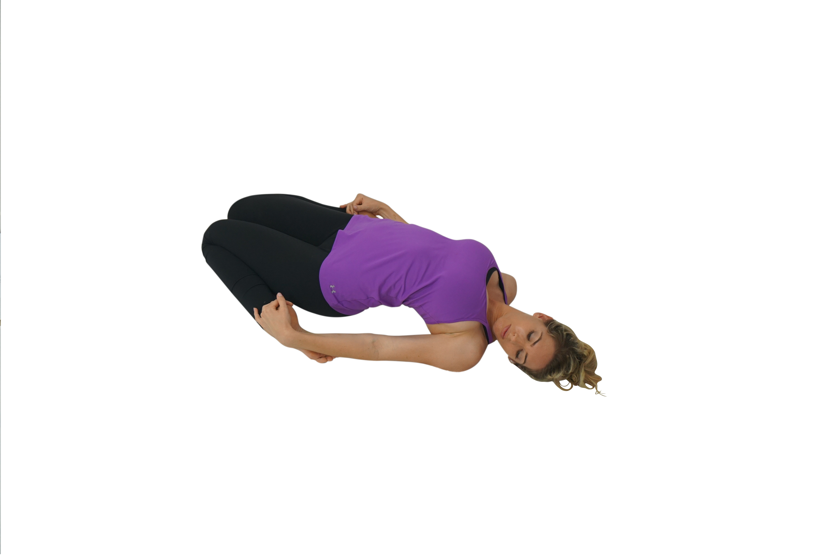 | INDICATIONS  - Knee pain  - Head aches,  - Lower Back Pain  Contraindications  - Knee surgery
Instructions
- Sit on mat knees touching
- Pull your calf muscles out to the sides
- Sit in between calves
- Bring hands to back of heels
- Bring one elbow down to the mat a t time then slowly lay back
- Hold for ten deep breaths

Modifications
- Use block under butt
- Don’t lay back

*All contraindications include recent surgery and pathologies.

Pigeon (Kapotasana)  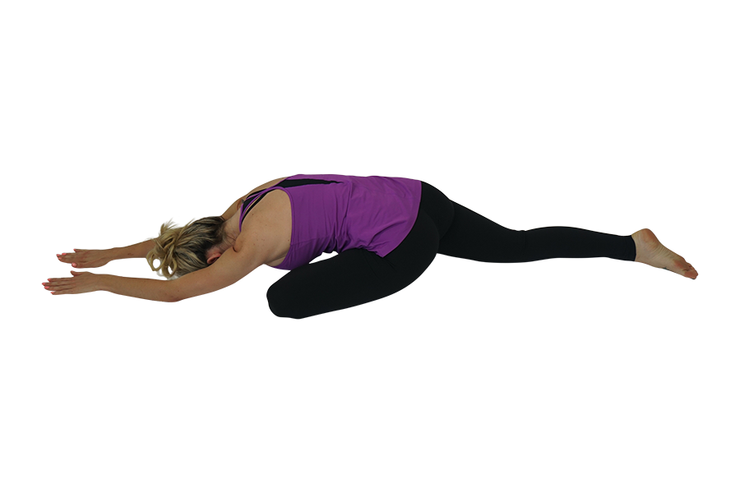 | INDICATIONS  - Lower back  - Headaches  - Arthritis  - Osteoarthritis  - Fibromyalgia  Contraindications  - THR
Instructions
- Start on all fours
- Bring your left knee to your left wrist
- Toes pointed slowly slide your right foot back until your leg is straight
- Try to bring your left toes towards your right wrist
- Keep your hips even
- Come down onto your forearm and rest your forehead
- Hold for ten deep breaths then switch sides

Modifications
- Place block under forehead
- Place block under thigh that the knee is bent
- Keep back knee bent as much as you need

*All contraindications include recent surgery and pathologies.

Reverse Table Top  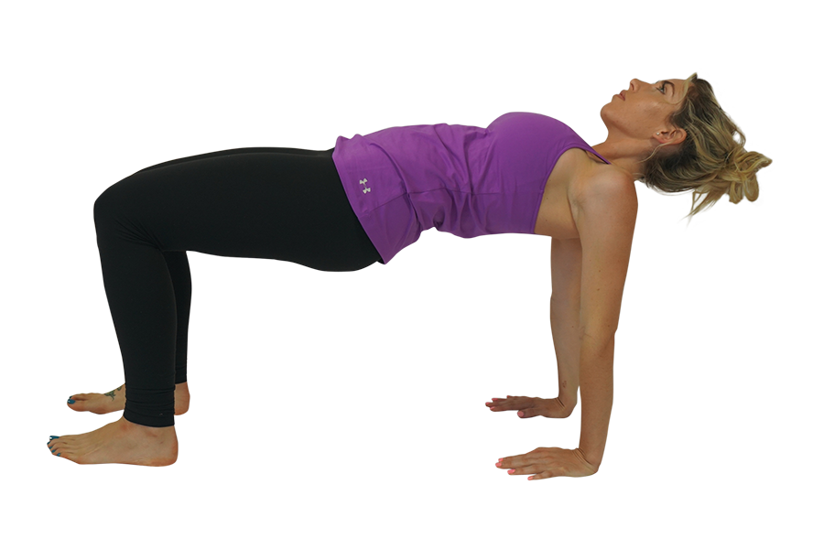 | INDICATIONS  - Carpal Tunnel  - Low back  - Posture  - Knee  - Hip  Contraindications  - Wrist issues
Instructions
- Begin by sitting on the floor with your legs extended
- Bring your hands behind your back
- Fingers pointing forward and wrist in align with your shoulders
- Bring your feet in and bend your knees
- Keep your knees over your ankles
- Slowly push your hips to the sky
- Hold for ten deep breaths

Modifications
- Don’t

*All contraindications include recent surgery and pathologies.

Supine Spinal Twist (Supta Matyendrasana)  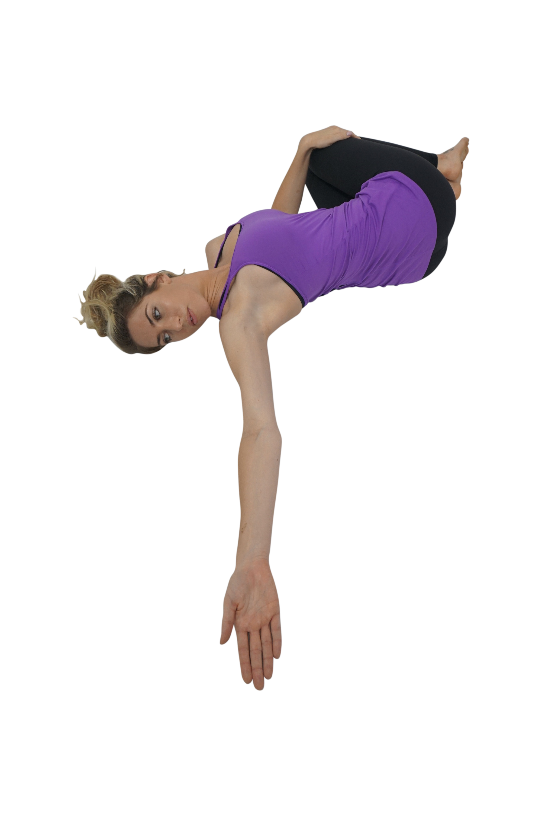 | INDICATIONS  - Lower back  - Knee pain  - Posture  - Arthritis  - Cervical  Contraindications  - Disc herniation
Instructions
- Start on your back legs extended
- Bring your knees to your chest
- Slowly let them fall to your left side
- Reach to your right with your right arm
- Gaze to your right
- Hold for ten deep breaths and switch sides

Modifications
- Keep soles of the feet on the mat and drift knees from side to side

*All contraindications include recent surgery and pathologies.

Fish Posture (Matsyasana)  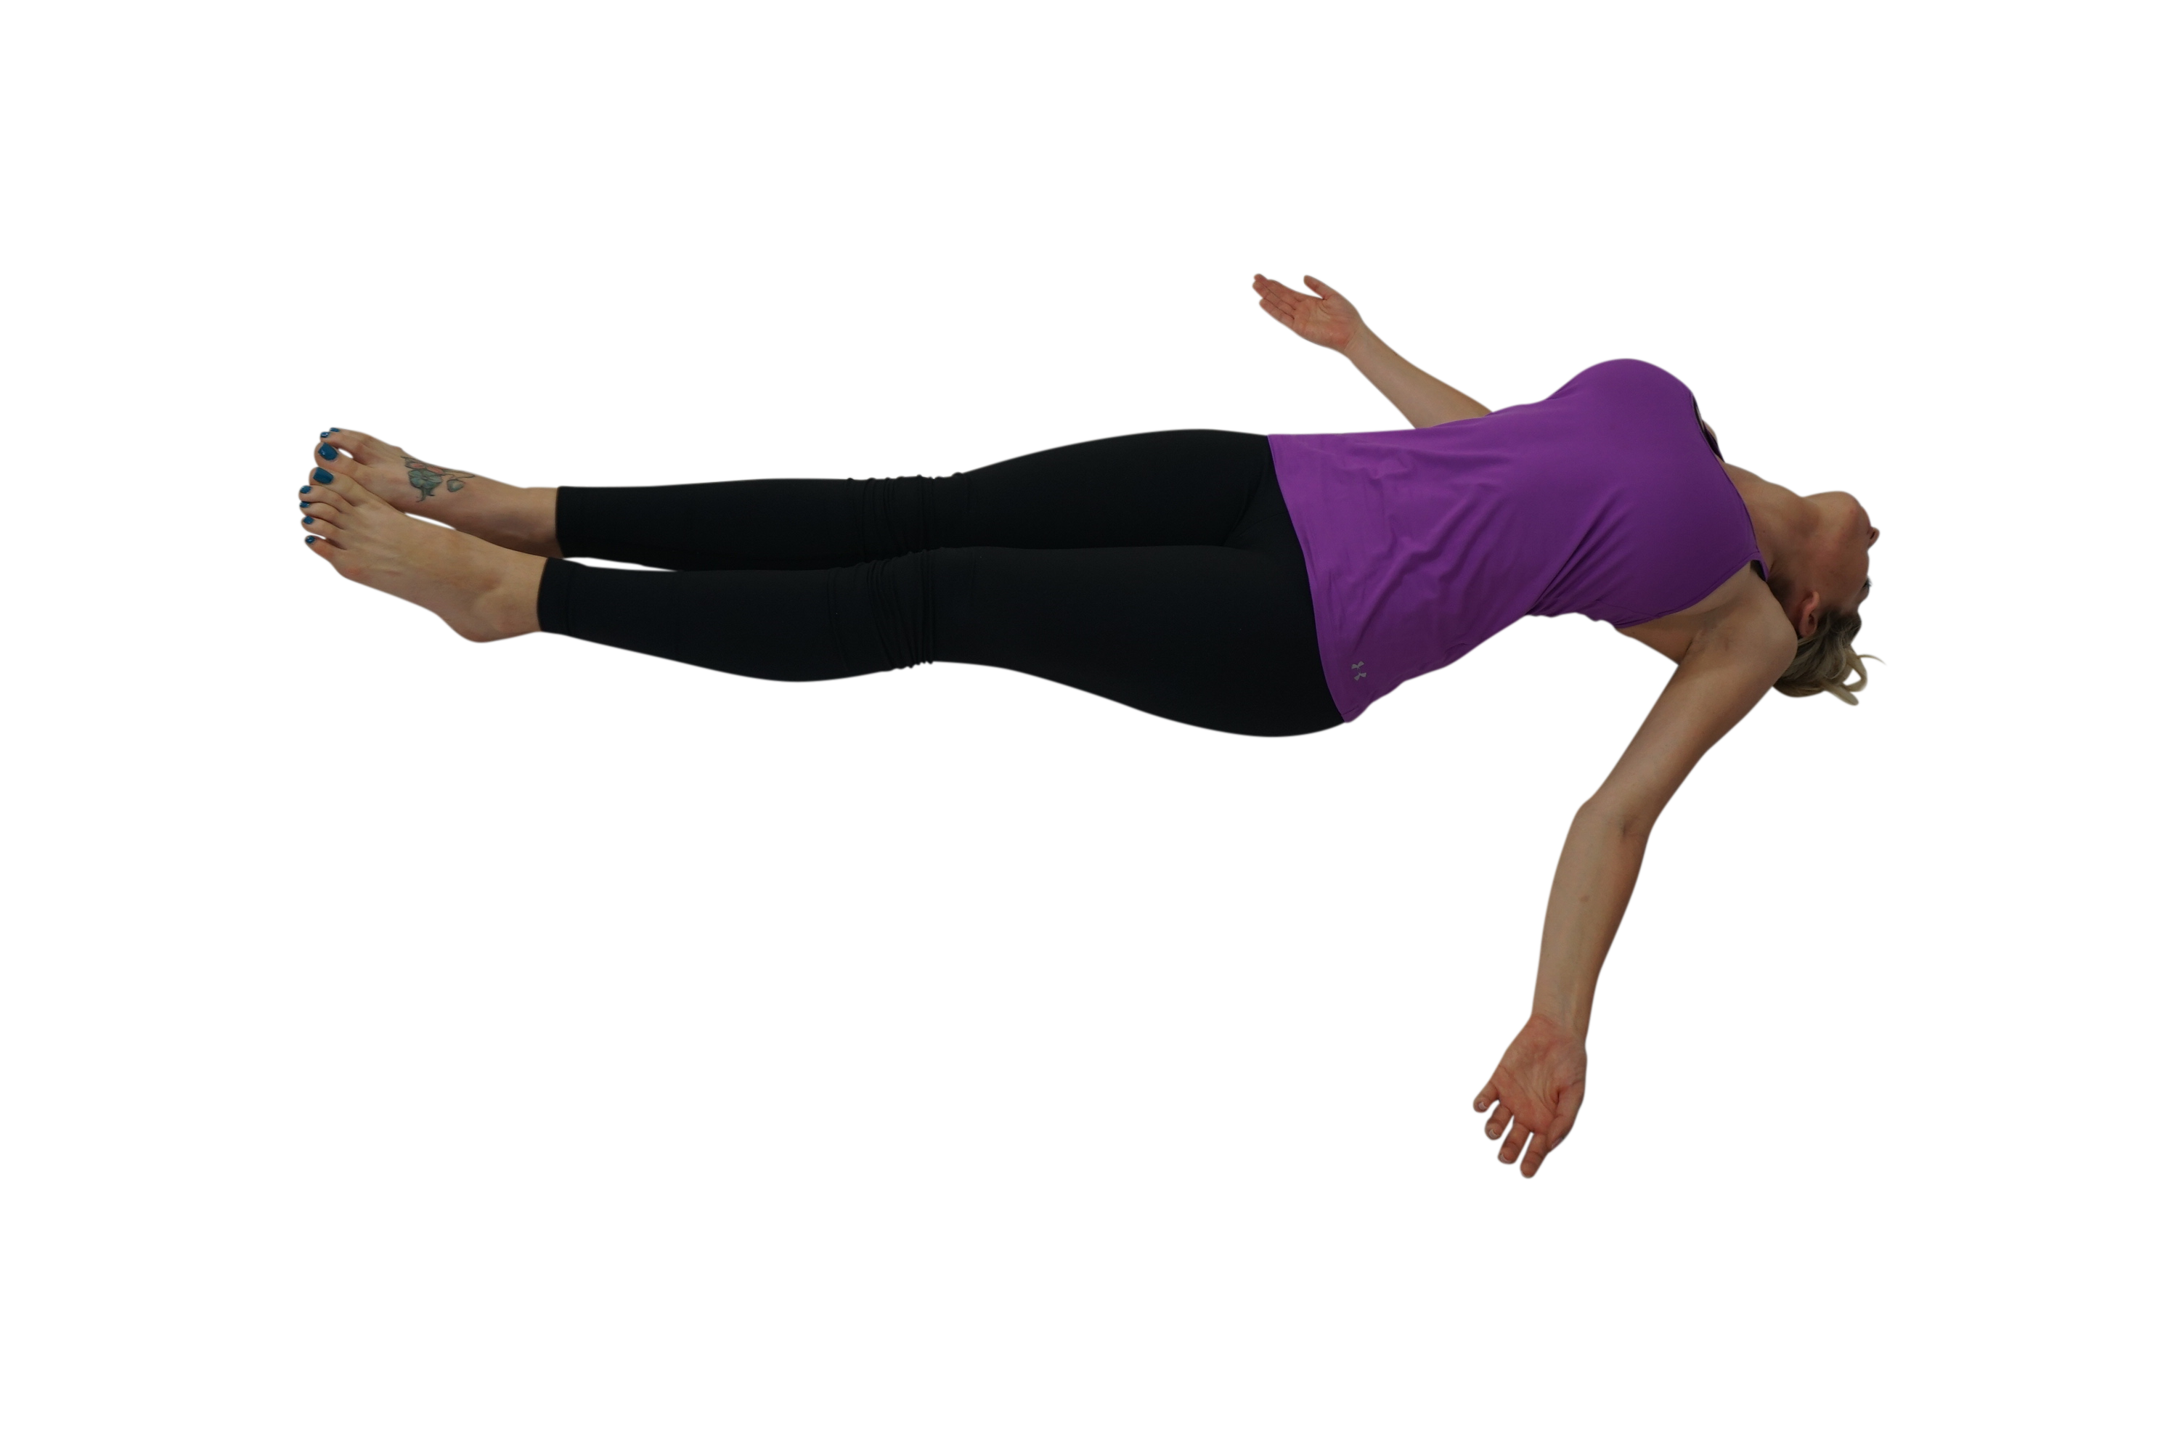 | INDICATIONS  - Shoulder Pain,  - Back  - Posture  - Fibromyalgia,  - Arthritis,  - Osteoarthritis  Contraindications  - Cervical fusion  - Rib pain  - Osteoporosis
Instructions
- Begin laying on back
- Place a block between your shoulder blades
- Relax your neck
- Let your arms fall out to your sides palms facing up
- Hold for ten deep breaths

Modifications
- If there is any strain in your neck place another block under the head

*All contraindications include recent surgery and pathologies.

